Virtusa React Training

B Sahil (221910304005)

Day 2 - 01/12/2022

1. To open VSCode from cmd, redirect to project directory, project file and type “code .” in the command prompt

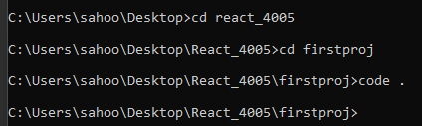

1. Create a biodata, and display your details.
2. Create a User.js file in src.
3. Copy the content from App.js into User.js. Make changes in code (Rename App as User in User.js) and add the biodata.
4. Import the User.js in Index.js
5. Now run the code using “npm start” in cmd.

User.js

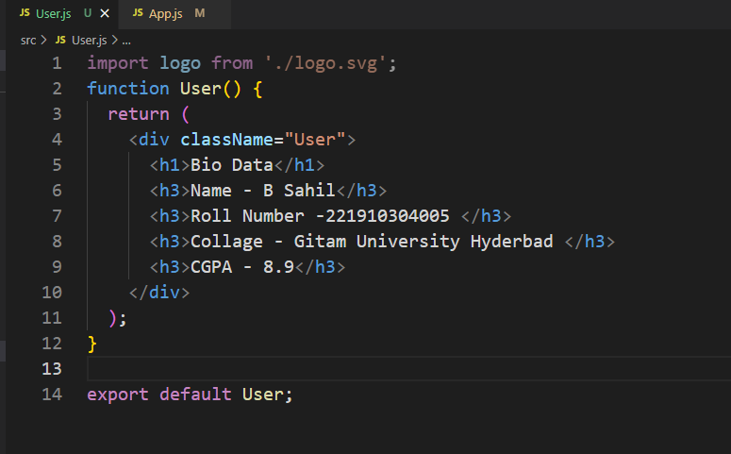

App.js

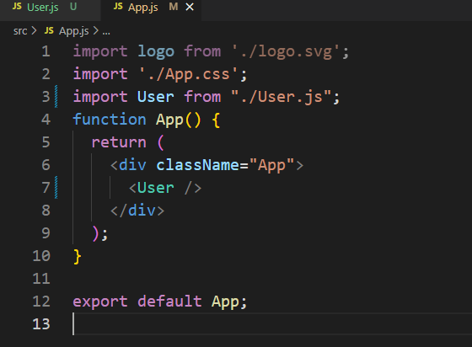

Index.js

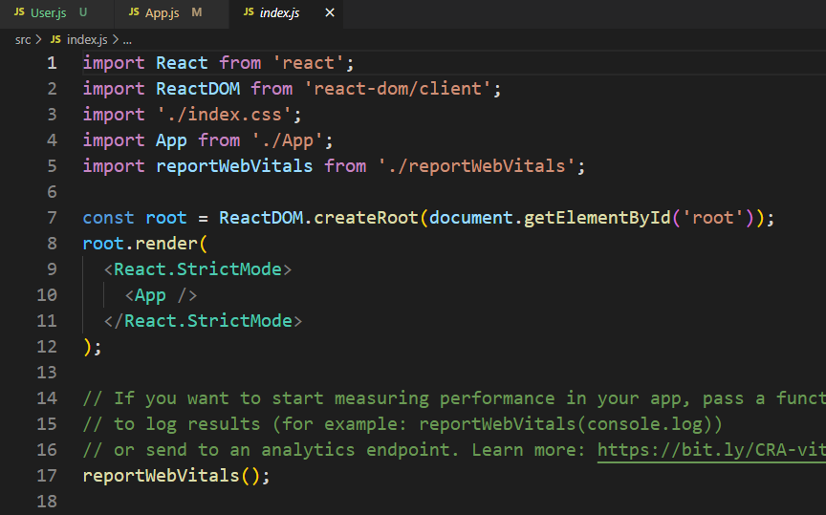

Output: -

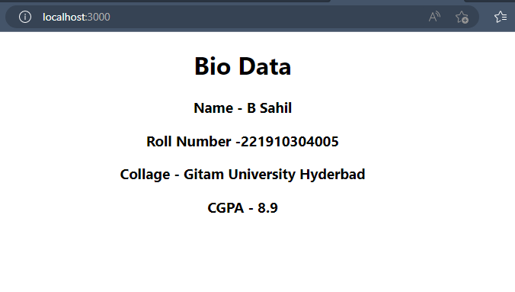

1. Create a file called “Gitam.js” in that file write the sentence “GITAM University is located in Hyderabad – 221910304005“. Execute the Gitam.js by importing the file into Index.js file.

Output: -

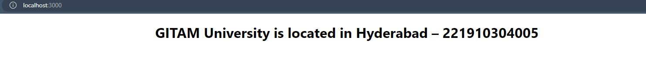

Index.js

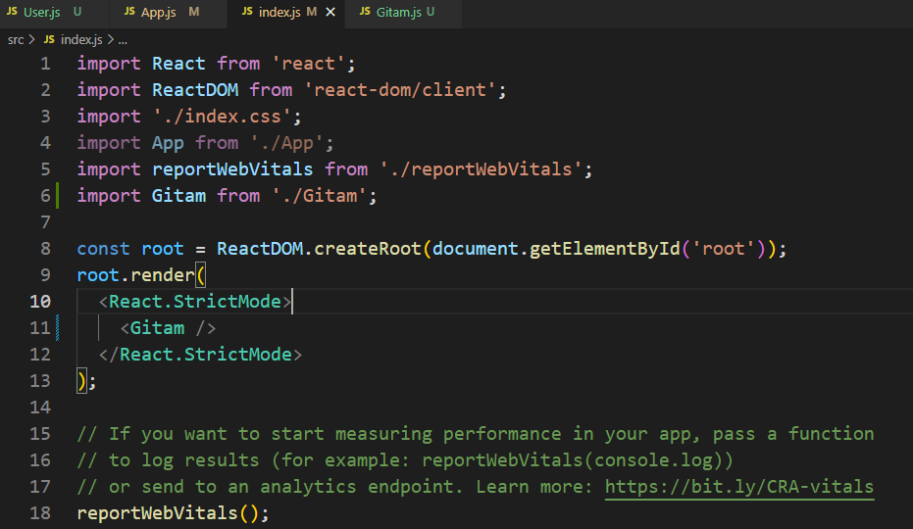

Gitam.js

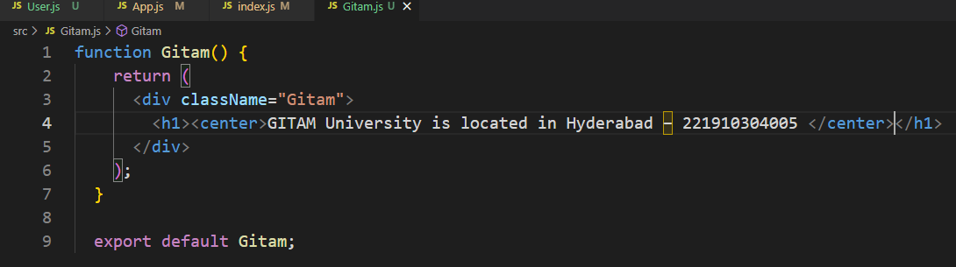

1. Print the sentence “GITAM University is located in Hyderabad – 221910304005“ three times.

(Here call the Gitam Function 3 times to get the expected output)

Output: -

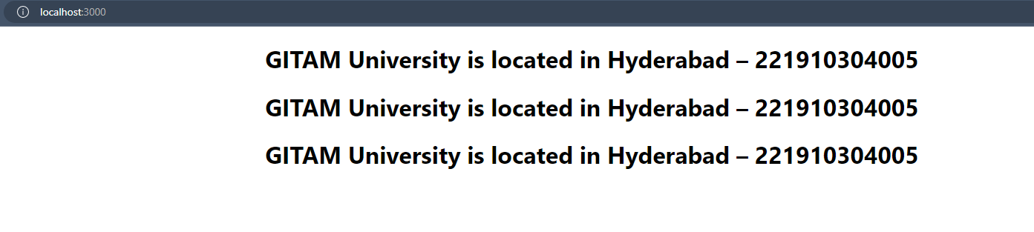

Index.js

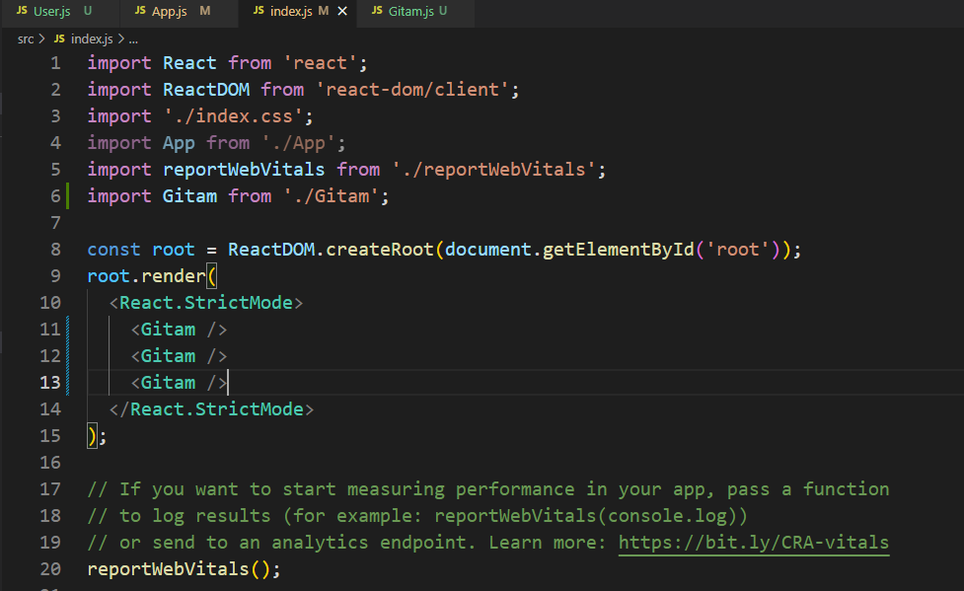

1. Create a new module (Module1.js) and import it into Gitam.js, then import Gitam.js into App.js then import App.js into Index.js.

Module1.js is used to print name and roll number.

Output: -

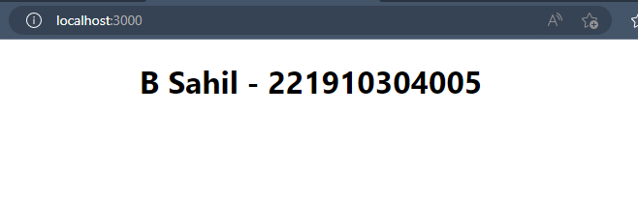

Module1.js

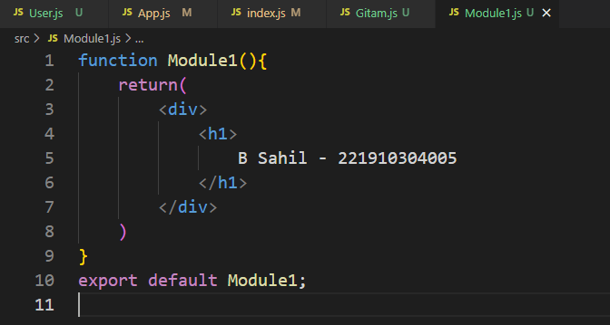

Gitam.js

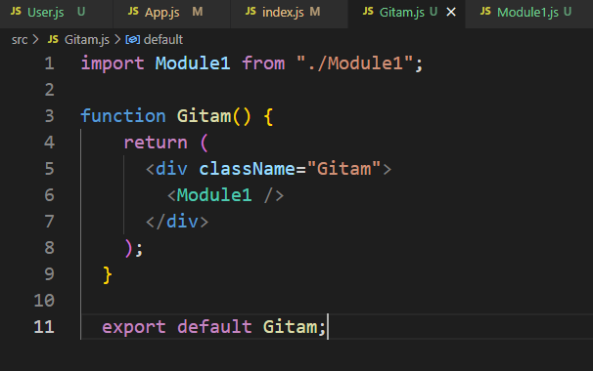

App.js

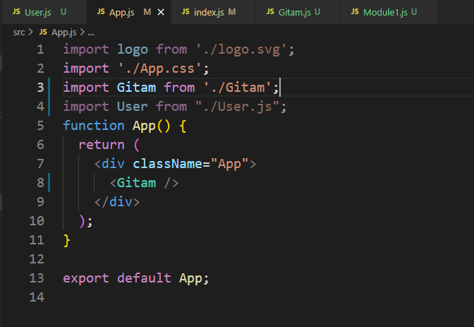

Index.js

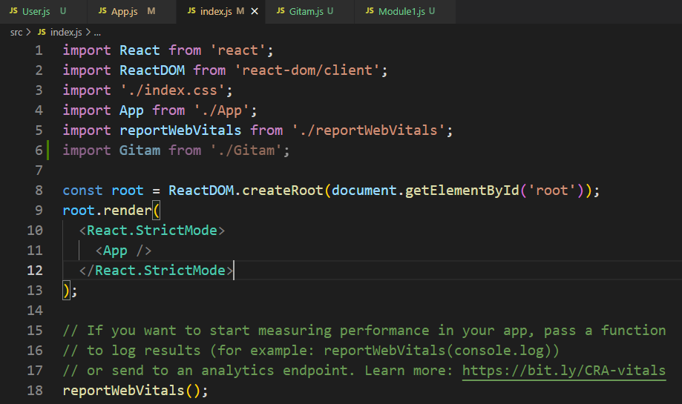

1. Create a file called “Abc.js” in that file print “Virtusa, India, England “.

Take another file(“Xyz.js”), in Xyz.js print the University and School along with the content of Abc.js.

Take another file(“Pqr.js”), in Pqr.js print your name along with the content of Xyz.js.

In App.js print your roll number along with the content of Pqr.js.

In Index.js import App.js and run the application.

Output: -

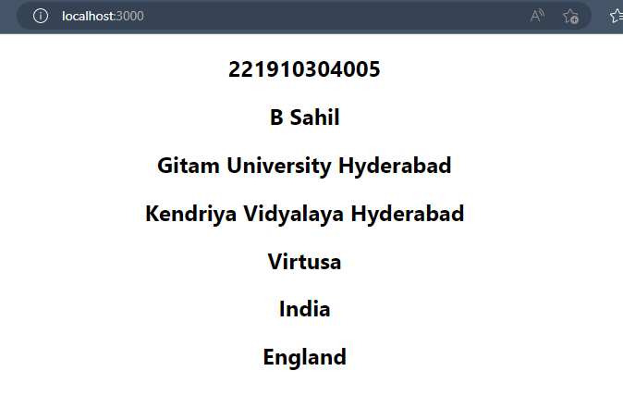

Abc.js

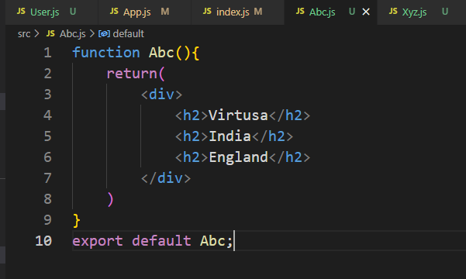

Xyz.js

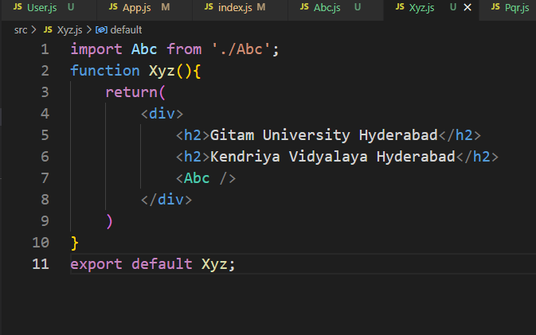

Pqr.js

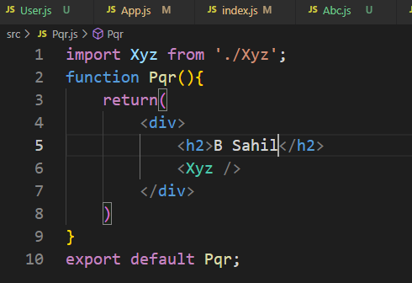

App.js

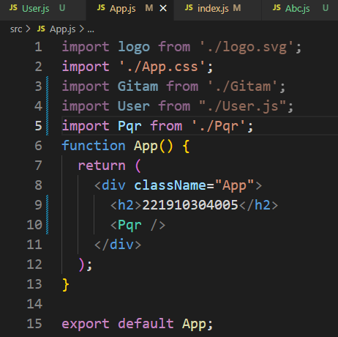

Index.js

33

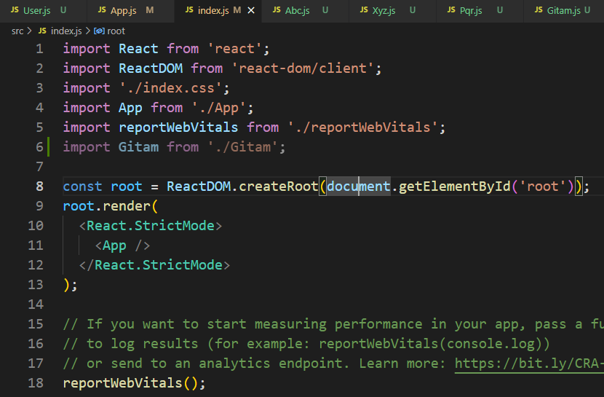

1. Create a functional component (your name), in the functional component write about yourself and call this functional component in index.js file.

Sahil.js

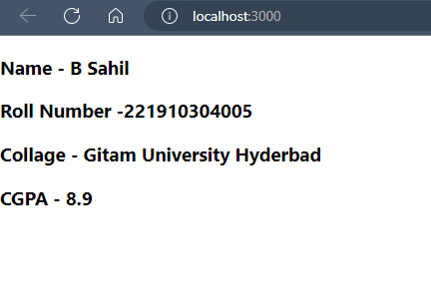

Index.js

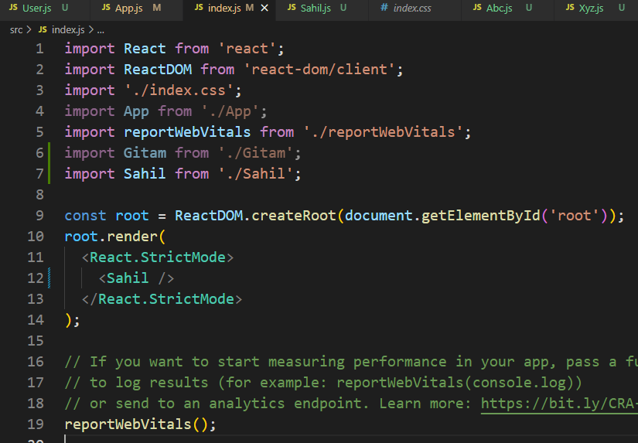

1. Create a functional component inside a functional component.

Output: -

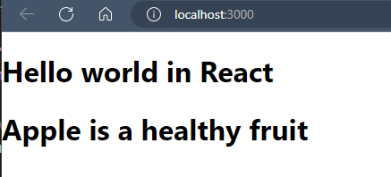

FunInFun.js

(Functional Component in Functional Component File)

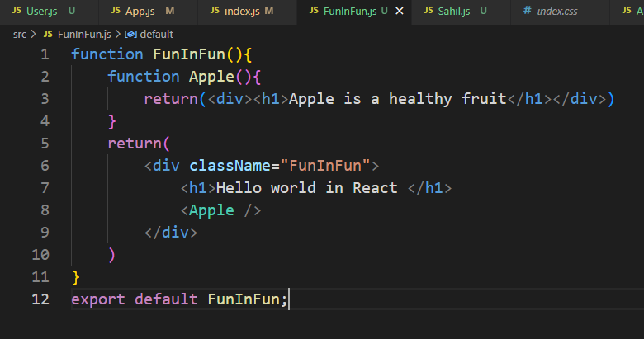

Index.js

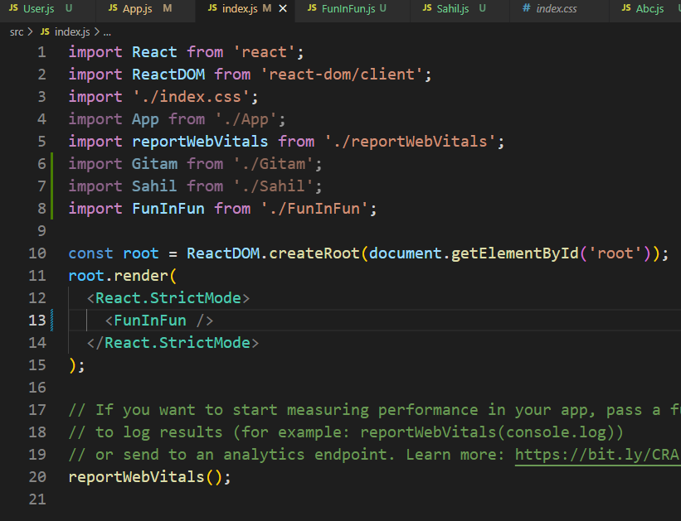

1. Create a functional component “Car” inside a functional component in “App”, also call Scooter in App.js, then import App.js in Index.js, then run the application.

Output: -

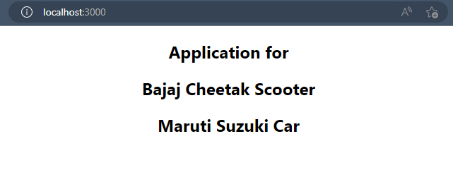

Scoter.js

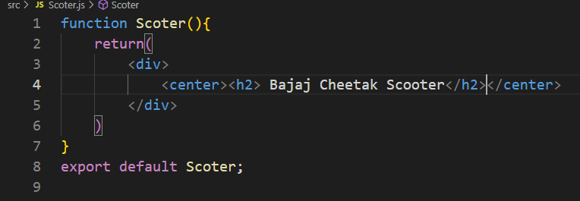

App.js

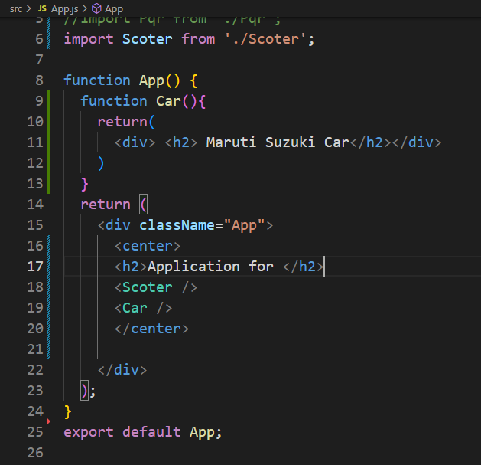

Index.js

